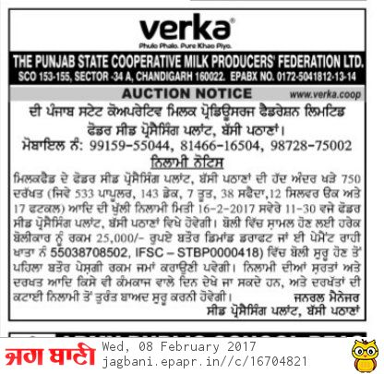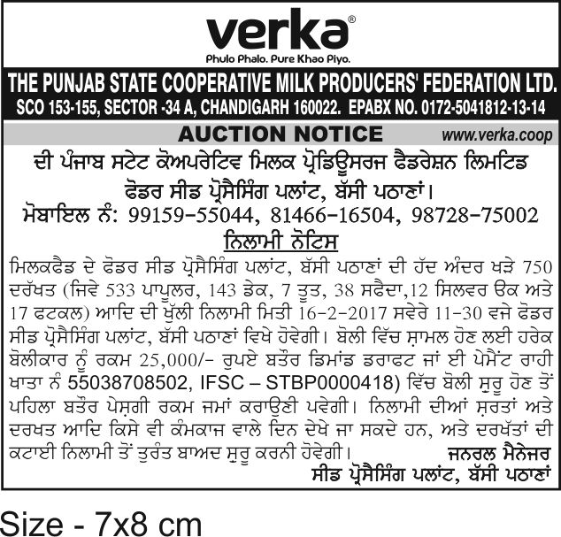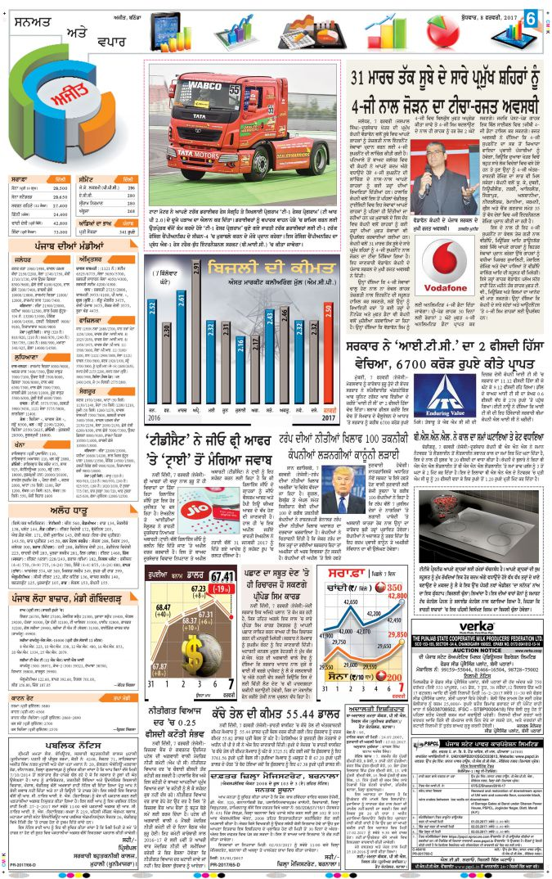daily ajit
THE PUNJAB STATE COOPERATIVE MILK PRODUCERS FED LTD
SCO NO.153-55, SECTOR-34/A, CHANDIGARH.

NO.PSF/PUR/140A/2017/ 114-116 Dated: 07.02.2017

M/s Degraphic Advertising
& Marketing,
SCO No. 6, Sector 30-D,
Chandigarh .

Subject: Publication of Auction Notice on 08.02.2017.

Dear Sir,

Please find enclosed herewith Auction Notice. You are requested to send this Notice for publication on 08.02.2017 by consuming minimum space in the following News Papers.
1) Jag Bani , Paper Language (As Per DAVP Rate)

2) Daily Ajit, Paper Language (As Per DAVP Rate)

It is also requested to send cutting of this Tender appeared in the above Newspapers along with Bill as well as copy of Tariff/rate for prompt settlement of your payment.

Thanking you,
Yours faithfully,

Manager Purchase,

Encl.: As above.

CC: Copy of the above is forwarded to the following for information and necessary action please.
- G.M Seed Processing plant (Bassi Bathna).
- Manager (F&A) Milkfed Head Office
3. Incharge (Computer) with the request to release enclosed Notice on Milkfed
Website.

