THE PUNJAB STATE COOPERATIVE MILK PRODUCERS’ FEDERATION LTD.
SCO 153-155, SECTOR -34 A, CHANDIGARH 160022. EPABX NO. 0172-5041812-13-14
NOTICE INVITING TENDER www.verka.coop
E-Tender is hereby invited for the supply following Items :
Sr.  No  . | Name of Item | Qty. | Consignee/Place Of Tender opening/contact numbers | Tender Cost in Rs | E.M.D  (Rs.) | Availability of Tenders online for bidding | Date & Time of Submission | Date of opening  of Technical Bid  and Commercial  Bid.
1 . | Sorghum Sudan Grass Hybrid (Multicut) Jowar Seed | Rate Contract  768 (Qtls)  Kharif-17 | Verka Corporate Office SCO NO.153-55,Sector-34A,Chandigarh(Ph. 0172-5041812-13-14 | - | 50,000/-  (Rs.Fifty thousand only) | 10.02.2017 From 4.00 PM | 27-02-2017 upto 12.00 O’ Clock | Technical Bid  on 27.02.2017  at 1.00 PM and  Commercial Bid  on 27-02-2017  at 1.00 PM
2. | Supply, installation and commissioning of Blast cooling units in existing 02 nos. cold stores & shifting of three VFD panels, etc. | Job Work | Verka Dairy Mohali (ph. 0172-2271784,5039350-351) | 500/- | 1,00,000/-  (Rs. One lac only) | 15.02.2017 from 02:00 PM | 02.03.2017 upto 09:00 AM | Technical Bid:  02.03.2017  at 11.00AM  Financial Bid:  09.03.2017  at 11:00AM
3. | Maize Hybrid Seed | 60 Quintal | -do- | 200/- | 10,000/-  (Rs. Ten thousand only) | 11.02.2017 from 10:00 AM | 28.02.2017 5:00 PM | 01.03.2017  11:30 AM
4. | Bajra Hybrid (Cutting) Seed | 45 Quintal | -do- | 200/- | 10,000/-  (Rs. Ten thousand only) | 11.02.2017 from 10:00 AM | 28.02.2017 5:00 PM | 01.03.2017  11:30 AM

For additional details regarding e- tendering please visit website etender.punjabgovt.gov.in

Bidders shall have to pay required Tender Processing fee through online mode only i.e. through debit/credit card for getting registered for e-tendering system. EMD should be made only through online mode i.e Credit/Debit card, NEFT/RTGS, OTC, Internet Banking. For participating in the above e-tender, the parties shall have to get themselves registered with our e-Tendering portal i.e. etender.punjabgovt.gov.in and get USER ID and Password well in time. Class 3 Digital Signature Certificate is mandatory to participate in e-Tendering process. For downloading tender through e-tendering, process flow, please contact e-Procurement help desk on given Nos. 9257209340, 8054628821 & 0172- 3934666-67, immediately so that process of timely registration and downloading the tender is completed in time by the date of tender opening.
Note:- Tender processing Fee is Non- Refundable.

MANAGER PURCHASE

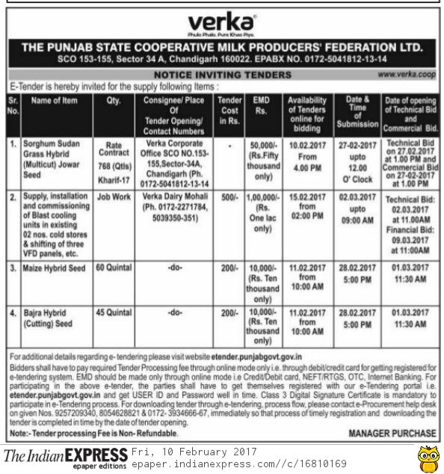

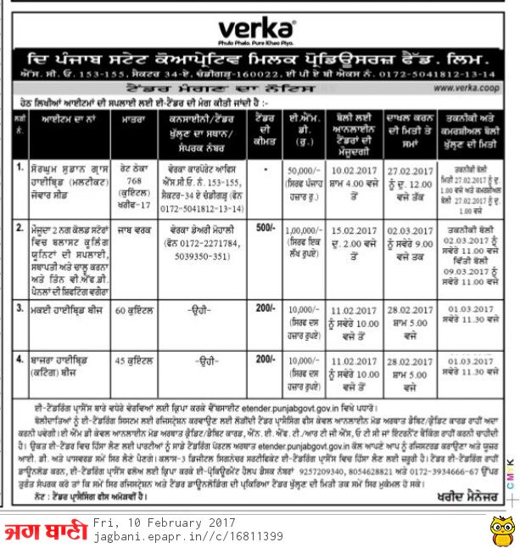

THE PUNJAB STATE COOPERATIVE MILK PRODUCERS FED LTD
SCO NO.153-55, SECTOR-34/A, CHANDIGARH.

NO.PSF/PUR/140A/2017 / 119-23 Dated: 09.02.2017

M/s Degraphic Advertising
& Marketing,
SCO No. 6, Sector 30-D,
Chandigarh .

Subject: Publication of E-Tender Notice on 09.02.2017.

Dear Sir,

Please find enclosed herewith e-tender Notice. You are requested to send this Notice for publication on 09.02.2017 by consuming minimum space in the following News Papers.
1) Jag Bani , Paper Language (As Per DAVP Rate)

2) Indian Express, Delhi (As Per DAVP Rate)

It is also requested to send cutting of this Tender Notice appeared in the above Newspapers along with Bill as well as copy of Tariff/rate for prompt settlement of your payment.

Thanking you,
Yours faithfully,

Manager Purchase,

Encl.: As above.

CC: Copy of the above is forwarded to the following for information and necessary action please.
- Manager (EDP) Verka Corporate Office.
- G.M Verka Dairy Mohali.
- Manager (F&A) Verka Corporate Office.
3. Incharge (Computer) with the request to release enclosed e tender Notice on verka Website.
Encl: E-Tender Notice

